SAKYA TSECHEN LING
EUROPEAN INSTITUTE OF TIBETAN BUDDHISM
FOUNDED BY VENERABLE KHENCHEN SHERAB GYALTSEN AMIPA RINPOCHE

His Holiness the 43rd Sakya Trizin Gyana Vajra Rinpoche

at Sakya Tsechen Ling, F-67520 Kuttolsheim
from 19th to 21st June 2026

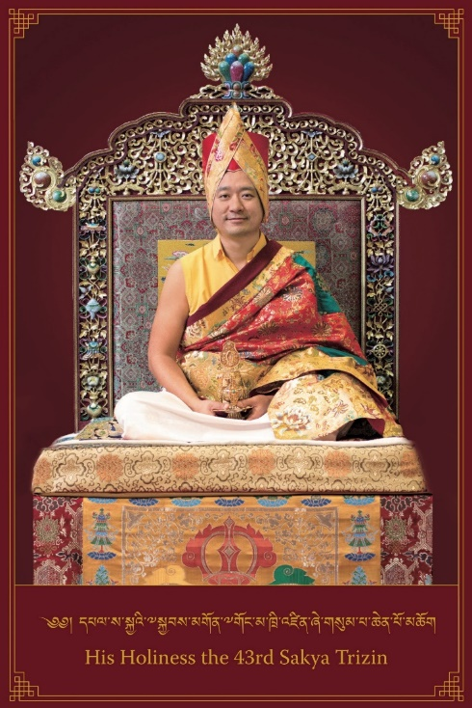
His Holiness the 43rd Sakya Trizin Gyana Vajra Rinpoche
His Holiness the 43rd Sakya Trizin, Gyana Vajra Rinpoche was born in Dehradun, Northern India, on 5th July 1979, the tenth day of the fifth lunar month of the Tibetan lunar calendar.

Throughout his life, Rinpoche has received from His Holiness Gongma Sakya Trichen Rinpoche most of the major initiations, empowerments, oral transmissions, blessings and pith instructions that are inherent to the Sakya Tradition, notably the profound Lamdre teachings of “Taking the Result as the Path”. Furthermore, Rinpoche has received numerous common and uncommon teachings from some of the prominent teachers of Tibetan Buddhism of our age.

Rinpoche has regularly turned the wheel of Dharma in centers across the world, giving teachings and initiations to disciples in the Americas, Europe, Asia and Australia. Rinpoche is fluent in English, Tibetan and Hindi.

Having fully realised the Buddha’s teachings, both sutric and tantric, Rinpoche personifies kindness and compassion. Combining ancient wisdom and contemporary knowledge, his unique teaching style is direct, profound, and relevant to our everyday reality, as complex Buddhist concepts are made accessible through examples that all students can easily relate to. Rinpoche chooses to guide his students along the Dharma path as a friend, while his openness and sense of humour bring joy to all who come into his presence.

Programme theme: Major Empowerment of Vajrakilaya

Vajrakilaya personifies the enlightened activity of all Buddhas, which subdues illusion and negativity in order to dispel obstacles to spiritual practice. The essential purpose of Vajrakilaya practice is to discover the absolute vajra nature, which can transform every dualistic obstacle into clear wisdom and compassion.
The Sakya order has countless exoteric and esoteric teachings. Of these, the Vajrakilaya cycle of teachings goes back the furthest in time. Its lineage is unbroken from the time of Padmasambhava and Khön Nagendra Raksita, through to the present time. Throughout the centuries, the successive proponents of the unbroken lineage of Vajrakilaya have all manifested very high realisations, through which they have performed great miracles, practically each of them. Many lamas and masters of various traditions highly praise the Vajrakilaya cycle.

Programme:

Friday 19th June 4.00 pm Introductory teaching

Saturday 20th June 9.00 am Preparation for the major Vajrakilaya empowerment
Participants who wish to do so may attend
2.30 pm Major Empowerment of Vajrakilaya (Day 1)

Sunday 21st June 09.00 am Preparation for the Vajrakilaya Major Empowerment
Participants who wish to do so may attend.
2.30 pm Major Empowerment of Vajrakilaya (Day 2)

N.B. This programme is subject to change.

Venue: Sakya Tsechen Ling Institute
5 Rond-point du Vignoble
67520 KUTTOLSHEIM

Directions: See this page on our website https://sakyatsechenling.eu/fr/contacts-et-infos/

Translations:
The teachings are delivered in English and translated consecutively into French and, as appropriate, simultaneously into German and Italian.

Registration:
Please read this entire document carefully beforehand to avoid any subsequent corrections.
Registration is then carried out via the Hello Asso platform via this LINK, which will guide you through the process.
Important note: Registration will close once capacity is reached.

Contribution:
The financial contribution, which excludes accommodation and meals, covers the travel and subsistence expenses of His Holiness and the monks accompanying Him, as well as other costs incurred by this seminar. The teachings themselves are free of charge. This contribution is not required of monks and nuns.

The contribution for the entire seminar from 19th to 21st June 2026, amounts to:

 | Sponsor | Standard rate | Student | Nuns/Monks
Contribution towards costs | €265 | €165 | €95 | €0
For insurance reasons, participants (including monks and nuns) in this event must be members of our association. | If you are not yet a 2026 member,  please add €10 to your payment  (occasional membership fee).

Meals:
Vegetarian meals will be served at the same place for those who wish to have them, at lunchtime and/or in the evening, and will require your help (preparation, washing up, etc.) if your physical condition allows. Meals must be booked and paid for in advance but will not be refunded in the event of cancellation.
Lunches will be available on Saturday 20 and Sunday 21 June, at a cost of €28 for both lunches, and dinners on Friday 19 and Saturday 20 June 2026, at a cost of €20 for both dinners.

Payment:
Payment – exclusively in euros – is handled via the Hello Asso platform. Please do not be surprised if this platform suggests an optional donation for itself; this is left to your discretion.

Reception & Formalities:
Registration and administrative procedures will take place at the venue (Sakya Tsechen Ling, 5 rond-point du Vignoble, 67520 Kuttolsheim) on Friday 19th June 2026 from 1 pm to 3.30 pm.

Volunteer support:
The organisation of such an event relies heavily on the commitment of a group of dedicated volunteers. We would like to thank you in advance for your help in setting up the teaching venue, with day-to-day tasks (during the day as well as in the evening, after the teachings), and with tidying up and cleaning at the end of the seminar.

Cars:
Please ensure you park your car in the Institute’s car park at the junction of Rue des Seigneurs and Rue de l’Abbaye.

Unless specifically asked to do so, please do not drive up to the rond-point du Vignoble, where the Institute is located. Thank you for your understanding.

Transport:
Bus (C.T.B.R.): https://www.ctbr67.fr/ Tel.: +33(0)9 72 67 67 67,
Line 205 Strasbourg – Willgottheim, Kuttolsheim-Centre stop.
Taxi13 Strasbourg, tel. +33 (0) 3 88 36 13 13

Childcare:
You will need to arrange childcare yourself, as the Institute is unable to provide this service. Thank you for your understanding.

Accommodation:
As accommodation is not available at the Institute, here are a few suggestions:

Tourist Offices

The tourist offices in Marlenheim, Wasselonne and Wangenbourg share a joint website: http://www.mossig-vignoble-tourisme.fr/

Marlenheim Wasselonne
Tel.: +33(0)3 88 87 75 80 Tel.: +33(0)3 88 62 31 01
1 Place de la Liberté 13 Place du Marché
67520 Marlenheim 67310 Wasselonne

Strasbourg:
17 Place de la Cathédrale, PO Box 70020, 67082 STRASBOURG CEDEX
Tel.: +33(0)3 88 52 28 28, https://www.visitstrasbourg.fr/

Hotels

La Ferme de Marie-Hélène
11 rue de l’Église 67370 ITTLENHEIM
Tel.: +33(0)6 47 29 10 60 Mr Bach
contact@fermemariehelene.com

Le Foyer de Notre-Dame de Reinacker
67440 REUTENBOURG
Tel.: +33(0)3 88 71 42 44
https://www.notredamedereinacker.fr/ accueil.reinacker@gmail.com

Hostellerie de l’ETOILE
1, Place du Gal Leclerc, 67310 WASSELONNE
Tel.: +33(0)3 88 87 03 02
www.hostellerie-etoile.com luxetoile@aol.com

Hostellerie REEB
2, rue Albert Schweitzer, 67520 MARLENHEIM
Tel.: +33(0)3 88 87 52 70
www.hostellerie-reeb.fr info@hostellerie-reeb.fr
(Special rate for guests from our Institute)

Hôtel LE CERF
30, Rue du Gal de Gaulle, 67520 MARLENHEIM
Tel.: +33(0)3 88 87 73 73
www.lecerf.com info@lecerf.com

La cour de Lise in Willgotheim
Tel.: +33(0)7 84 11 04 44
www.lacourdelise.fr contact@lacourdelise.fr

Les Chambres du Marlenberg
3, Place du Kaufhaus, 67520 MARLENHEIM
Tel.: +33(0)6 82 43 10 56
michele.schwartzweber@orange.fr

Peace Valley
Bloecherplatz 67440 MARMOUTIER
Tel.: +33(0)6 73 80 87 32
peacevalleynagym@icloud.com

Holiday cottages

www.gites-de-france.com including

La Vallée, guest house, Kuttolsheim Les Hirondelles, Wangen
https://21-lavallee.com/ Direct line to: +33(0)6 83 20 19 94
Tél. : +33(0)3 88 33 17 05

Campsites

Wasselonne Campsite
www.campingwasselonne.fr campingdewasselonne@onlycamp.fr
(Discount if booked via the website)
Tel: +33(0)7 49 08 10 24

