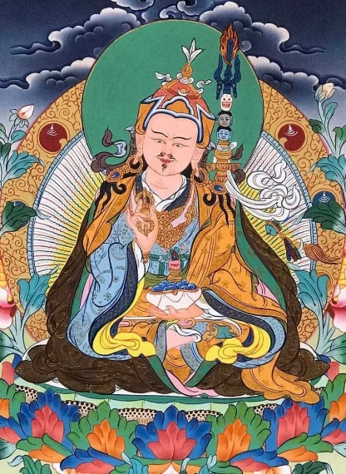
SUMMER-RETREAT ON THE GURU YOGA OF PADMASAMBHAVA
1st – 8th AUGUST 2026

ON SITE at SAKYA TSECHEN LING F-67520 KUTTOLSHEIM
& ONLINE THROUGH ZOOM

Guided by Khenpo Tashi Sangpo Lag

Dear Dharma friends,

The Sakya Tsechen Ling Institute is pleased to organise this Guru Yoga of Padmasambhava together with Tsok Offering summer retreat.
During this retreat we focus on the practice of the Guru Yoga of Padmasambhava.

In the beginning of the daily fourth session there will be teachings on the sadhana.

PARTICIPATION PREREQUISITES FOR TEACHINGS & MEDITATION SESSIONS:
- Already having received the initiation of the Guru Yoga of Padmasambhava from a qualified Sakya master.
- OR participation in the initiation of the Guru Yoga of Padmasambhava conferred by Khenpo Tashi Sangpo Lag at the beginning of the retreat on 1.8. at 16.00 o’clock to the participants in the temple (without streaming)

TRANSLATIONS:
The teachings will be given in English and translated into French.
Translations in another language – Italian, German, and Dutch – will be arranged if we receive a min. number of requests per language by 15th July 2026.

PROGRAM OF THE RETREAT:
Saturday 1st August 2026
16.00 – 18.00 Initiation of the Guru Yoga of Padmasambhava (no streaming, only for participants in the temple)
18.30 - 20.00 First meditation session on the Guru Yoga of Padmasambhava

Sunday 2.8. - Friday 7.8.2026
07.00 - 08.00 Meditation on the Guru Yoga of Padmasambhava
10.00 – 11.30 Meditation on the Guru Yoga of Padmasambhava
14.00 – 15.30 Meditation on the Guru Yoga of Padmasambhava
17.00 – 18.00 Teaching on the sadhana of the Guru Yoga of Padmasambhava
18.00 - 19.00 Meditation on the Guru Yoga of Padmasambhava & Mahakala ritual.

Saturday 8 August 2026
07.00 - 08.00 Meditation on the Guru Yoga of Padmasambhava & Long-life prayers for Their Holinesses
End of the retreat.
10.00 – 11.00 Tara Ritual (optional)

CONTRIBUTION:
Min. € 70.- for online or on-site retreat (not including food and accommodation).
For on-site retreat, and after pre-registering specifying your wishes for accommodation and meals, you will receive a specific email indicating your contribution to the costs.
You can make your payment in one of the ways described at https://sakyatsechenling.eu/en/online-payment/ .
We thank you much in advance.

REGISTRATION & PARTICIPATION LINK:
In order to participate, we invite you to register by clicking HERE FOR ON-SITE RETREAT or HERE FOR ONLINE RETREAT until 15th July at the latest.
Those who wish to participate on-site are invited to register early as the number of places is limited.
Together with the receipt/confirmation of your registration you will receive further information and for online retreat the participation link.

With warm regards, the office of Sakya Tsechen Ling.

